Project Design Phase-II

Data Flow Diagram & User Stories

Date | 02 November 2025
Team ID | NM2025TMID00163
Project Name | Laptop Request Catalog Item
Maximum Marks | 4 Marks

Data Flow Diagrams:
A Data Flow Diagram (DFD) is a traditional visual representation of the information flows within a system. A neat and clear DFD can depict the right amount of the system requirement graphically. It shows how data enters and leaves the system, what changes the information, and where data is stored.

In the project “Laptop Request Catalog Item”, Data Flow Diagrams (DFDs) illustrate how laptop request submissions are processed within the ServiceNow system. The DFD shows the interaction between the employee (requester), the ServiceNow platform, and the IT department or approver to ensure a smooth and automated request workflow. When an employee submits a laptop request form through the Service Catalog, the system captures key details such as the laptop model, justification, and additional accessories. If the employee selects the “Additional Accessories” checkbox, the form dynamically displays the “Accessories Details” field, which becomes mandatory through a UI Policy.

The system validates all inputs before forwarding the request to the IT department for review and approval. Additionally, a “Reset Form” UI action allows users to clear all entered details instantly, improving usability. Once the configuration is complete, the update set is exported and committed to another instance, ensuring version control and deployment consistency. This DFD effectively represents how user input, system logic, and administrative controls interact to streamline and automate the laptop request process.

Example:

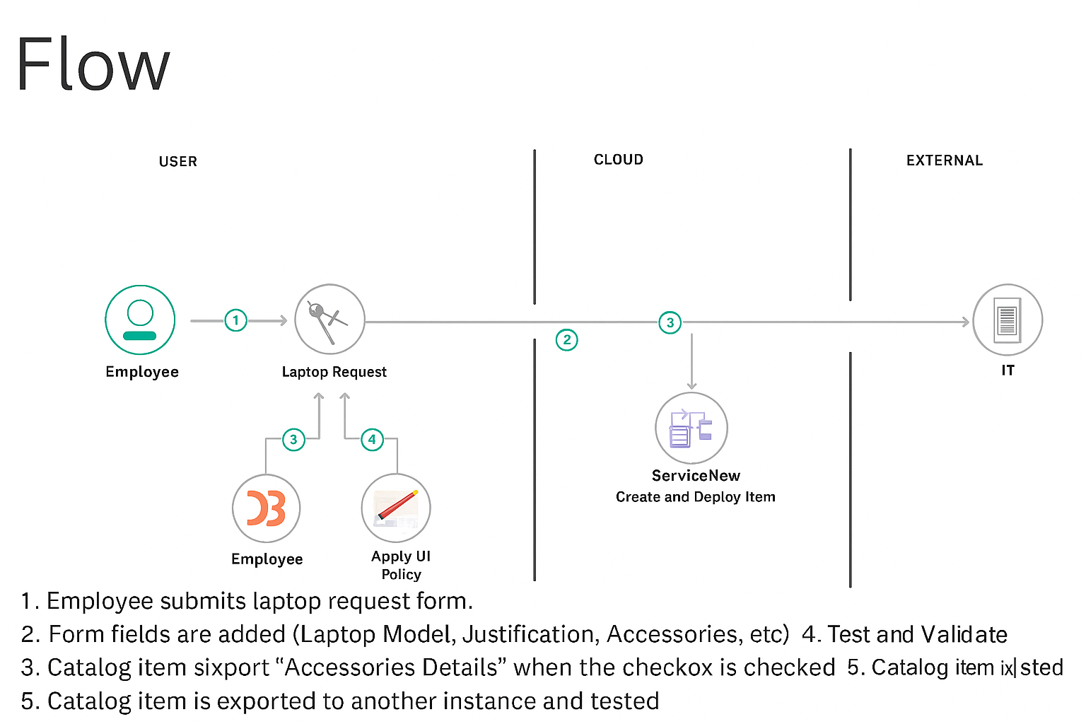
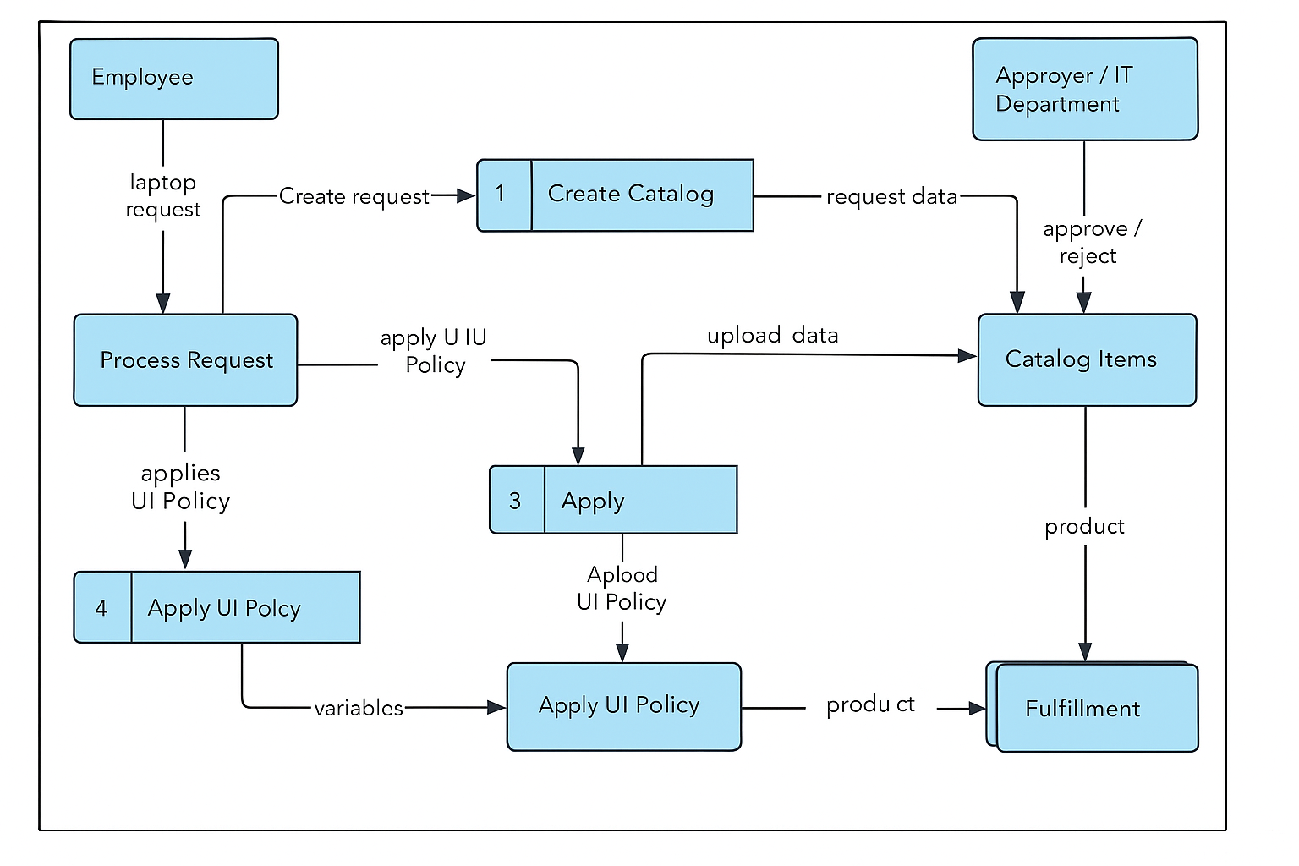

User Stories
User stories define what different users need from the system in simple, goal-focused language.In this project, they help ensure employees can efficiently request laptops, the system dynamically responds to user selections, and administrators can manage and deploy the catalog item smoothly.

User Type | Functional Requirement (Epic) | User Story Number | User Story / Task | Acceptance Criteria | Priority | Release
Employee | Submit Laptop Request | USN-1 | As an employee, I want to submit a laptop request form so that I can get the required laptop for work. | The form should allow entry of laptop model, justification, and accessories, and submit successfully. | High | Sprint-1
System (Auto-check) | Dynamic UI Policy | USN-2 | As a system, I must display the “Accessories Details” field only when “Additional Accessories” is selected, to guide accurate data entry. | The field should appear dynamically and become mandatory only when the checkbox is checked. | High | Sprint-1
Administrator / Developer | Create and Deploy Catalog Item | USN-3 | As an administrator, I want to create, test, and export the Laptop Request catalog item using update sets for deployment across instances. | The update set should export and import successfully, preserving all catalog configurations and scripts. | High | Sprint-2
IT Department (Approver) | Review and Approve Requests | USN-4 | As an IT department member, I want to view and approve laptop requests submitted by employees. | Approved requests should display correctly in the service catalog and update the requester’s status. | Medium | Sprint-3

